Ropes & Knots

WHY???? Protect lives. Protect lives and secure gear/equipment.

Why Learn different knots? Properly tied knots will secure or hold whatever you need and will then untie without difficulty

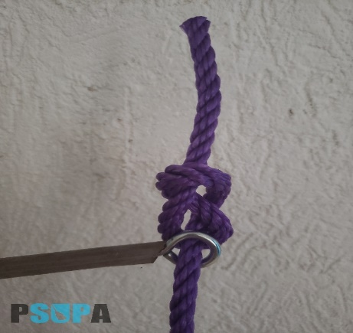

Figure 8 Knot (Stopper Knot)
Use- A quick and simple to tie knot that
prevents the rope from coming through a hole
Advantage – Strong knot that is easy to undo even after
being under heavy load
Disadvantage- Can fall undone easily

How to tie: https://www.animatedknots.com/figure-8-knot

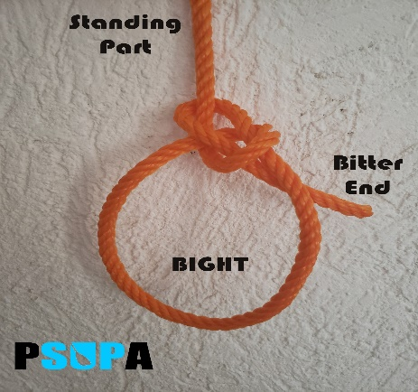
Bowline Knot
Use- A quick and simple to tie knot with a standing loop
Advantage – Even after heavy load it will come undone easy
Disadvantage- Cannot be undone while under load

How to tie: https://www.animatedknots.com/bowline-knot

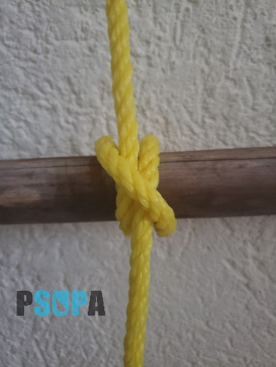

Clove Hitch
Use- Widely considered one of the most important knots
Advantage – Line can be slipped to adjust knot from either end
Disadvantage – Can slip

How to tie: https://www.animatedknots.com/clove-hitch-knot-using-loops
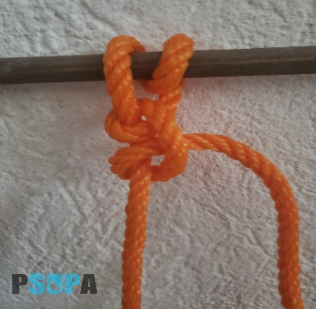
Round Turn & 2 half hitches

Use- A versatile knot to fasten around a rail or hook.
Advantage – A good versatile knot to tie up to a rail or
hook and will not slip like a clove hitch can
Disadvantage – None

How to tie: https://www.animatedknots.com/clove-hitch-knot-using-loops

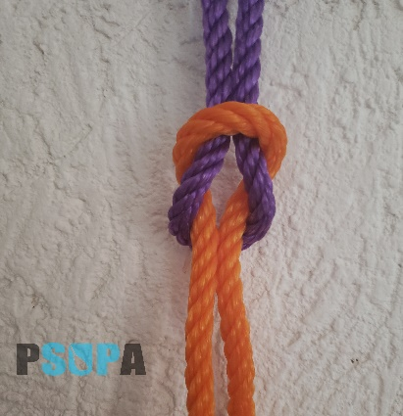
Square Knot (Reef Knot)

Use- A good way to join 2 ropes together.
Advantage – It will come undone easily
Disadvantage - It will come undone easily

How to tie: https://www.animatedknots.com/square-knot

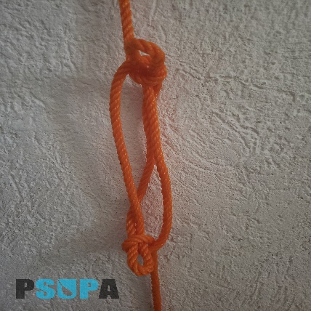
SheepShank Knot

Use- A quick way to shorten a rope or take up slack.
Advantage – It will stay secured as long as under load
Disadvantage - It will come undone easily when load is removed

How to tie: https://www.animatedknots.com/sheepshank-knot

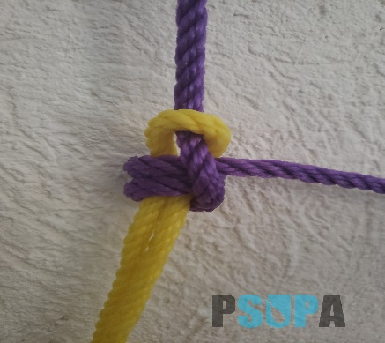
Quick Hitch Knot

Use- Good for pulling another rope
Advantage – quickly released by pulling on the end
Disadvantage – no other real uses for this knot

How to tie: https://www.animatedknots.com/quick-hitch-knot

Types of lines / ropes

Nylon – (three-strand or braided)
Advantage - It doesn't snag, it is easy to splice, and it is considerably less costly than braided rope. It has great strength, "gives" under load to absorb energy. Resists mildew and rot
Disadvantage – Can easily snag, loses up to 25% of strength when wet

Polypropylene – (that yellow rope) that's commonly used to tow skiers, wake boards and dinghies.
Advantage – Floats, Cheapest to buy
Disadvantage – Less resistant to damage from UV, slips or comes untied easier

Polyester – (Dacron)
Advantage – wears better than polypropylene and retains strength when wet. highly abrasion resistance and long lasting.
Disadvantage – It will chafe easily, Ends need to be sealed to prevent fraying

Natural Material – (manila, sisal, hemp, and cotton)
Advantage – Strong with minimal stretch
Disadvantage – Will shrink, it typically costs more, will rot, become brittle or mildew

